Numerical Method to PDE

Homework #3

Heng Chi 653987966

Problem #1

Some formulation of several steps:

Step #2:

Once we get the coordinates of the nodes of each elements, denoted: , we can get the Jacobian of each elements, having the form: . Consequently, the inverse of transposed Jacobian and the determinant of the Jacobian can be easily obtained.

Step #3:

The gradients of the shape functions in the reference coordinate have the following form:



Step #4

By using the Jacobian, we can get the gradients of shape functions in the physical coordinates:



Step #5

The stiffness matrix can be obtained as follows:

 where, is the area of the reference triangle.

Step #6

The right hand side of the term can be obtained as follows:

 where,  is the integral of shape function over the reference domain.

All the formulations listed above is implemented in template provided in Python. And the results are as follows:

1. Case with k=0.1, f=0;

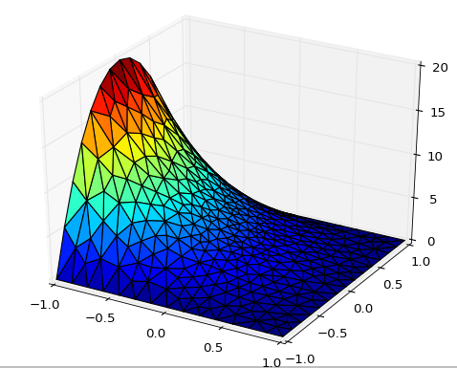 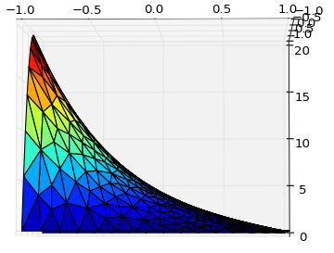

1. Case with k=0.5, f=25 if $\sqrt{x^{2}+y^{2}}≤0.25$ and 0 otherwise

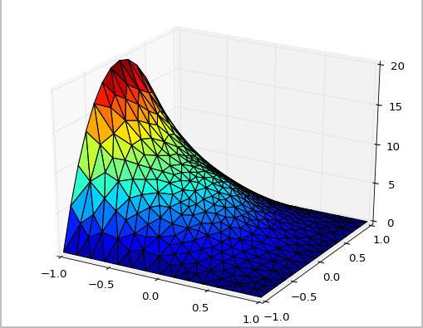 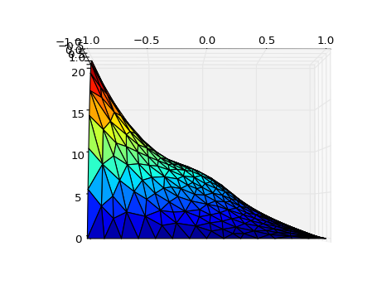

1. Case with k=25 if $\sqrt{x^{2}+y^{2}}≤0.25$ and 0.1 otherwise; f=25 if $\sqrt{x^{2}+y^{2}}≤0.25$ and 0 otherwise

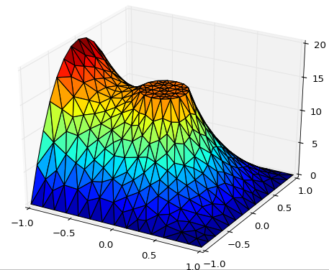 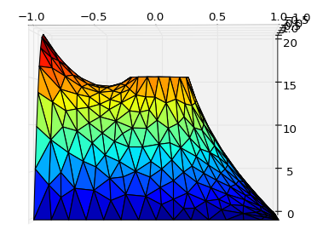

Problem 2

The same problem is performed in Dolfin and results are listed as follows. For each step, please refer to the source code that I submit.

1. Case with k=0.1, f=0;

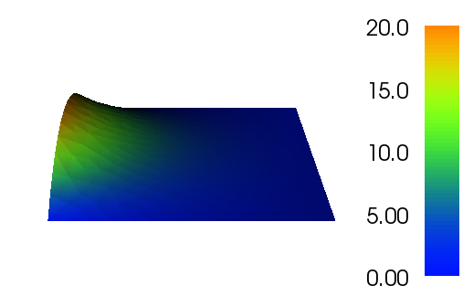 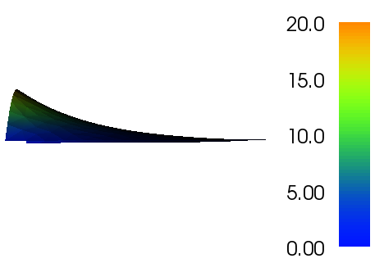

1. Case with k=0.5, f=25 if $\sqrt{x^{2}+y^{2}}≤0.25$ and 0 otherwise

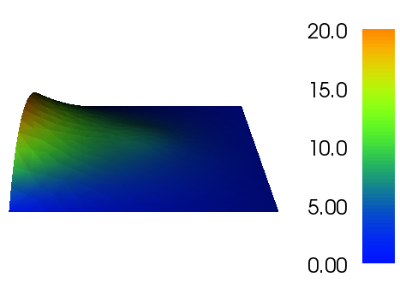 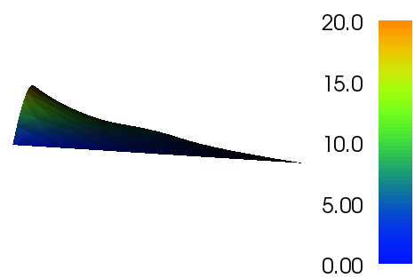

1. Case with k=25 if $\sqrt{x^{2}+y^{2}}≤0.25$ and 0.1 otherwise; f=25 if $\sqrt{x^{2}+y^{2}}≤0.25$ and 0 otherwise

